3D METALFORGE FACILITY RECEIVES AMERICAN BUREAU OF SHIPPING’S WORLD’S FIRST CERTIFICATION FOR 3D PRINTING

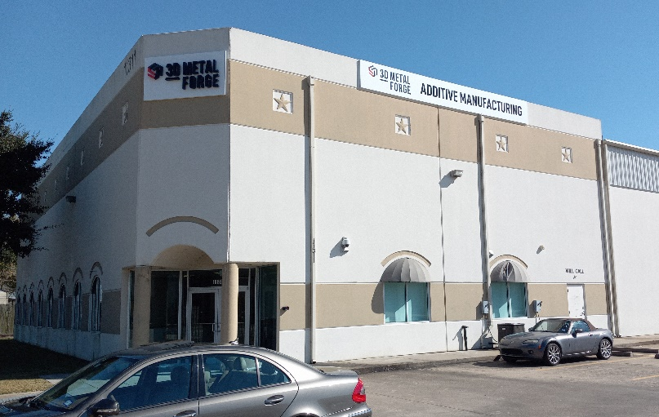
29 AUGUST 2022: 3D Metalforge Limited (ASX: 3MF) (‘3D Metalforge’ or the ‘Company’),
is pleased to announce its Houston, Texas manufacturing facility’s certification by the American Bureau of Shipping (ABS) for the additive production of metal parts. The company’s Houston facility was opened in the mid-2021 and 3DMF is very pleased to be the world’s first Additive Manufacturing (AM) facility approved by ABS under their new Additive Manufacturing standard. The certification comes after a rigorous process of site inspection, test sample printing and exhaustive examination of the Company’s processes and procedures. This provides a significant competitive advantage to 3DMF as the only company certified to supply parts requiring “class approval” to ABS global customer base.

This builds on the successful certification of parts by ABS installed on ConocoPhillips Polar Tanker “Endeavour” and later removed for testing and proven to be performing well and the on-going collaboration with ABS on the Maritime Port Authority of Singapore’s Joint Industry Program (JIP) 2 program.

“This is a very important step for the Company and fully establishes our Houston facility as one of the leading Additive Manufacturing facilities in USA. We are extremely pleased to have worked with ABS to achieve this certification after many years of collaboration,” said Matthew Waterhouse, 3D Metalforge CEO.

This certification is part of 3D Metalforge’s growth strategy of focusing on oil & gas and maritime sectors and building a strong foundation of quality systems, assurance and quality part production. It also builds on 3D Metalforge’s Singapore manufacturing facility already being ISO certified by Lloyd’s Register (LR). The ABS certification demonstrates once again 3D Metalforge’s commitment to continual improvement, business efficiency, greater reliable quality of processes and products, and higher levels of customer satisfaction.

The benefits of this facility and process approval includes increasing the range of customers and parts 3DMF can work with to include those that require parts to be “class approved” before installation, it further differentiates 3DMF in proposals to potential customers and is a clear independent endorsement of the quality of the parts produced by 3DMF. The facility and process approval demonstrates the 3DMF Houston facility is considered capable to manufacture AM part as outlined in the process/product approval in accordance with ABS Rules for Materials and Welding Part 2 (2022) and ABS Guide for Additive Manufacturing (2021).
###
For more information please contact:

Company enquiries Media enquiries
Matthew Waterhouse Bob Lytle
CEO, Managing Director Marketing Manager
info@3dmetalforge.com bob.lytle@3dmetalforge.com

ABOUT 3D METALFORGE
3D Metalforge (ASX: 3MF), founded in 2015, is a leading Additive Manufacturing (AM) company that supports a growing multinational industry-leading client base with their advanced proprietary 3D additive manufacturing systems. The Company offers a full range of in-house AM printing services from design and engineering, material advisory, diagnostics and testing, to printing and post-production certification to the latest industry and API standards. Its approach to industrial production, its proprietary processes and eco-friendly technology produce high-demand parts faster, better and more cost-effectively with less environmental impact and greater sustainability than conventional manufacturing.

ABOUT ABS
For more than 150 years, ABS has been at the forefront of marine and offshore energy innovation. We work alongside our partners tackling the most pressing technical, operational and regulatory challenges so the marine and offshore industries can operate safely, securely and responsibly. ABS is committed to setting standards for safety and excellence as one of the world’s leading classification organizations. In a constantly evolving industry, ABS works alongside its partners tackling the most pressing technical, operational and regulatory challenges so the marine and offshore industries can operate safely, securely and responsibly. We provide traditional classification services as well as on-the-ground technical services in asset performance, energy efficiency, environmental performance and life cycle management.

